Dax 25 day challenge  
https://curbal.com/25-days-of-dax-fridays-challenge

Day1 : How many current product cost less than $20  
  
Solution : 37  
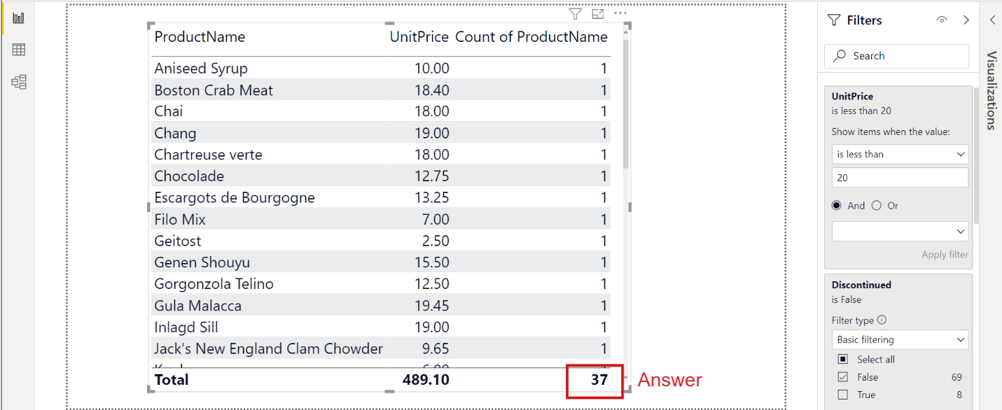  
  
  
Day2 :Which product is the Most Expensive?  
ans: Cote de Blaye  
  
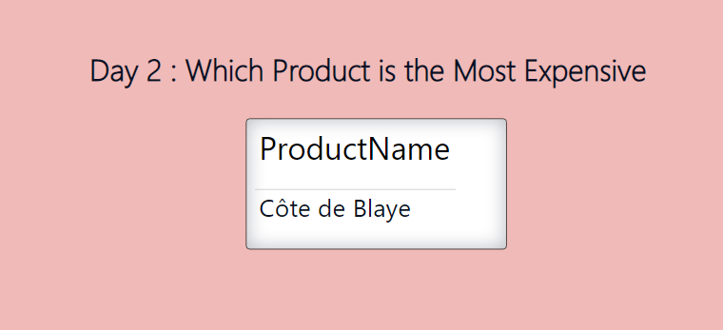  
  
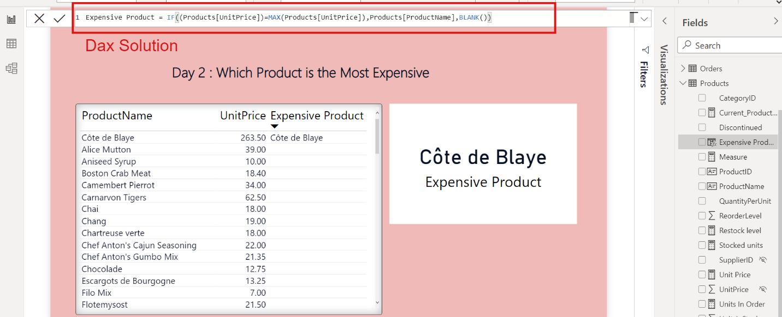  
  
  
Day 3: Which is the Average Unit Price of our Product?  
  
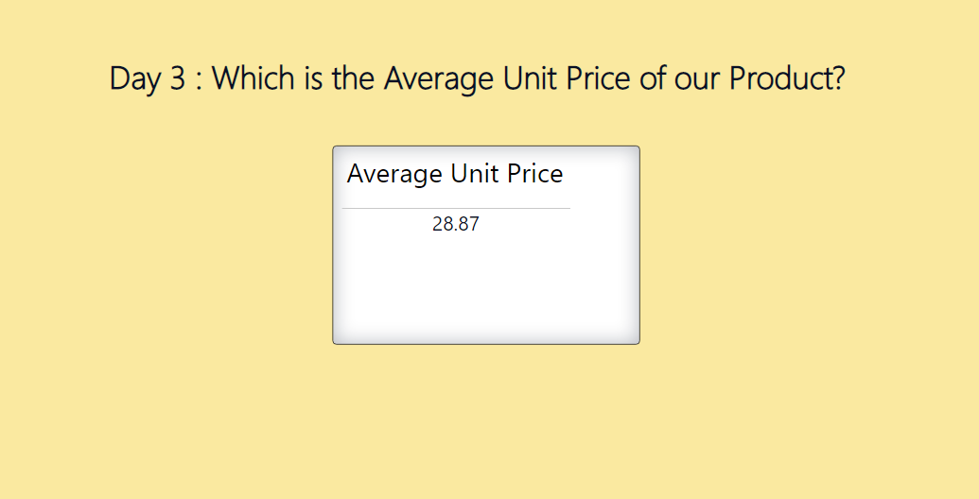  
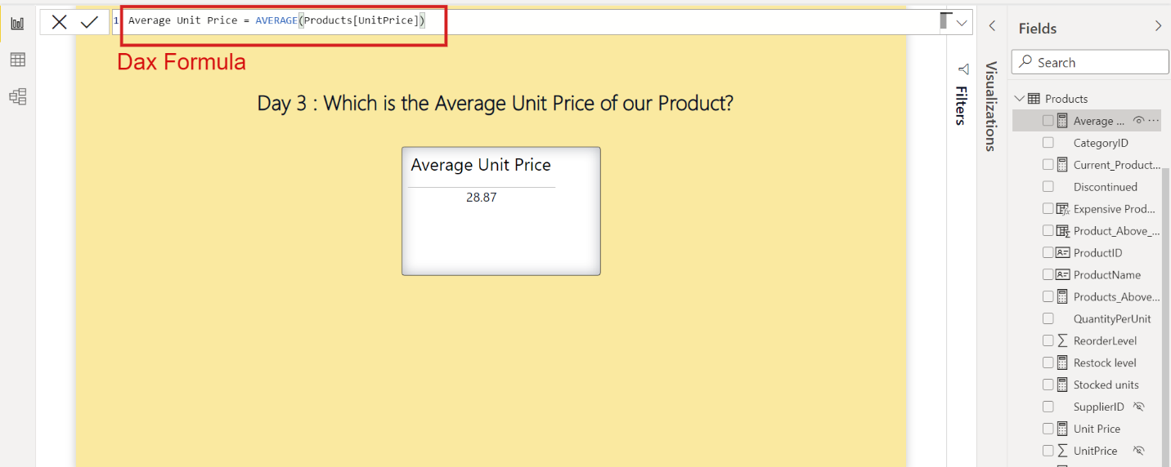  
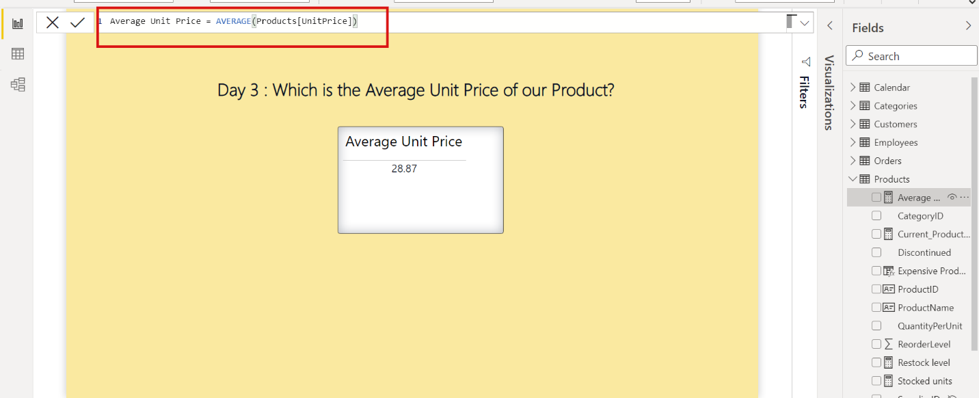  
  
  
  
  
Day4 : How Many Products are above the average Unit Price?  
  
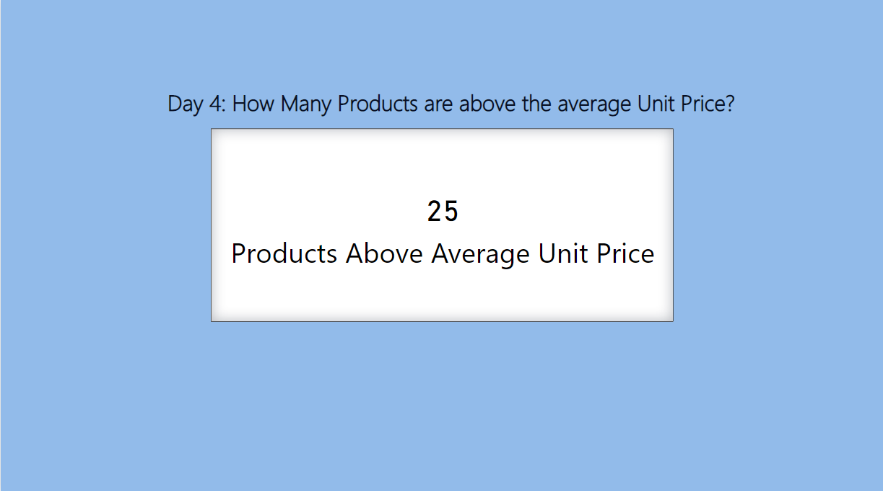  
  
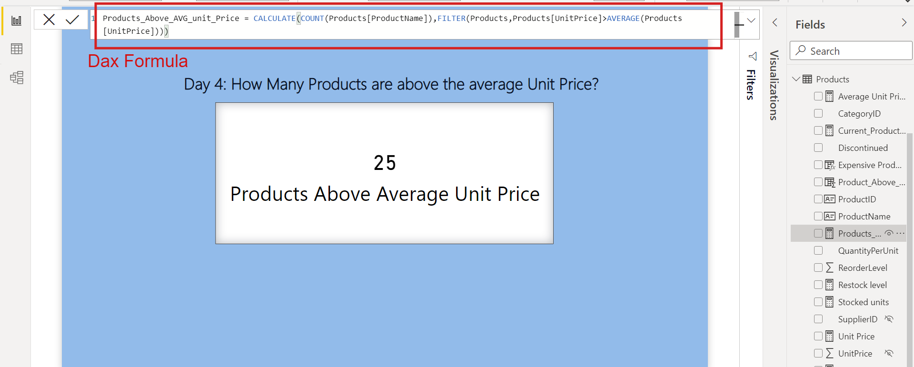  
  
Day5: How Many Products cost between 15 and 25 ?  
CALCULATE(COUNT(Products[ProductName]),FILTER(Products,Products[UnitPrice]>=15&&Products[UnitPrice]<=25))

CALCULATE(COUNT(Products[ProductName]),FILTER(Products,Products[UnitPrice]>=15&&Products[UnitPrice]<=25))  
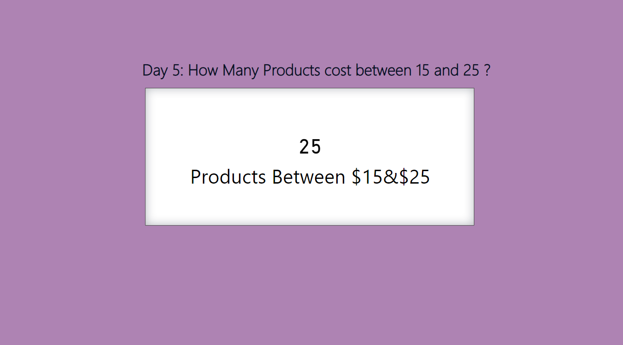  
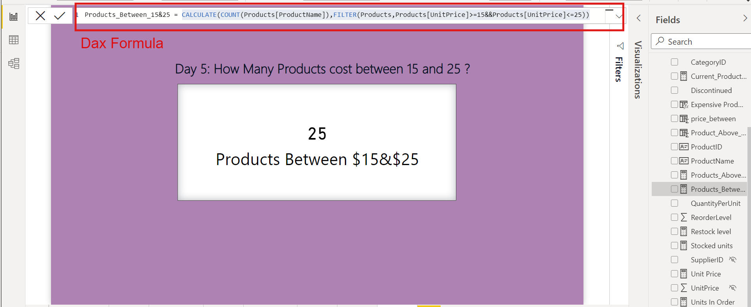  
  
  
  
Day 6: What is the average size for all years and all customer?  
Ans : 23.86  
  
Dax Formula :   
  
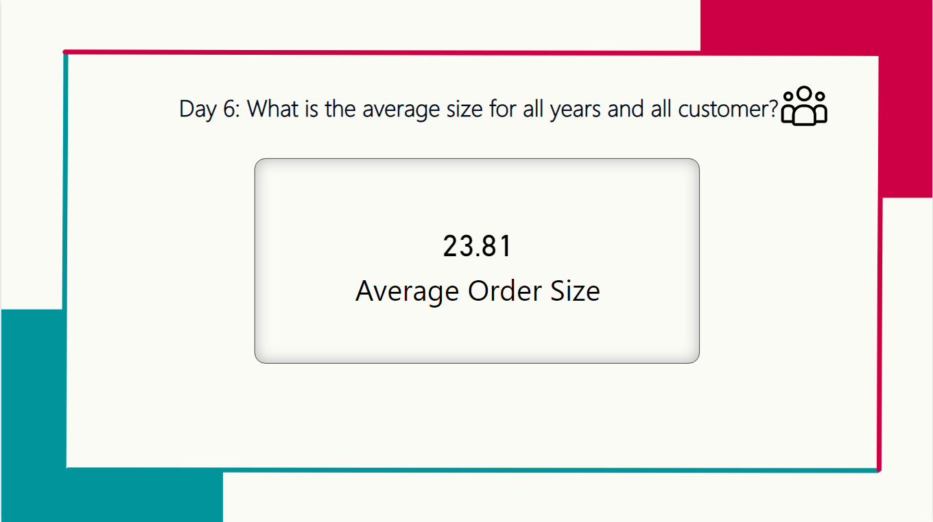  
  
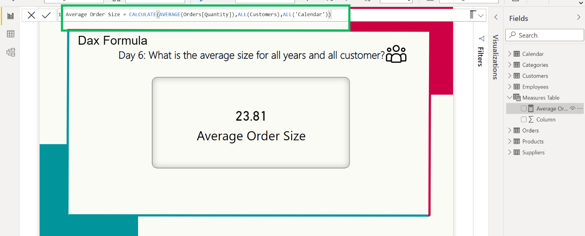  
  
  
Day 7: What is the Order value in $ of Open Orders? (Not Shipped Yet)  
Ans: 27443.76  
  
Dax Solution : CALCULATE(SUM(Orders[_Sales]),FILTER(Orders,Orders[ShippedDate]=BLANK()))  
  
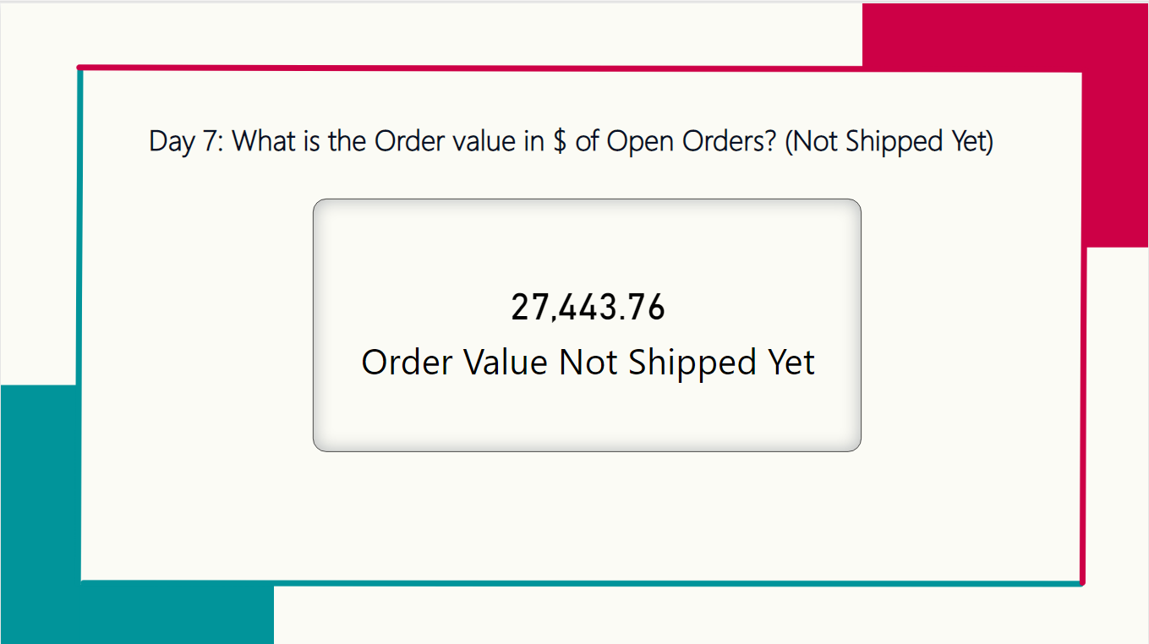

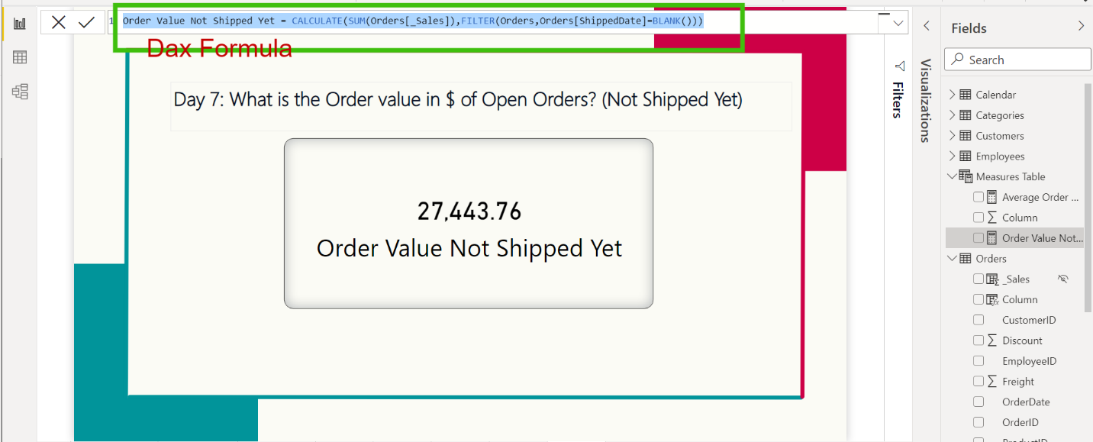  
  
  
Day8: How Many Orders are Single Item (Only one product Ordered)?  
ans : 137  
dax Solution: COUNTROWS (FILTER ( ALLSELECTED ( Orders[OrderID] ), CALCULATE ( COUNT( (Orders[ProductID] ) ) = 1)))

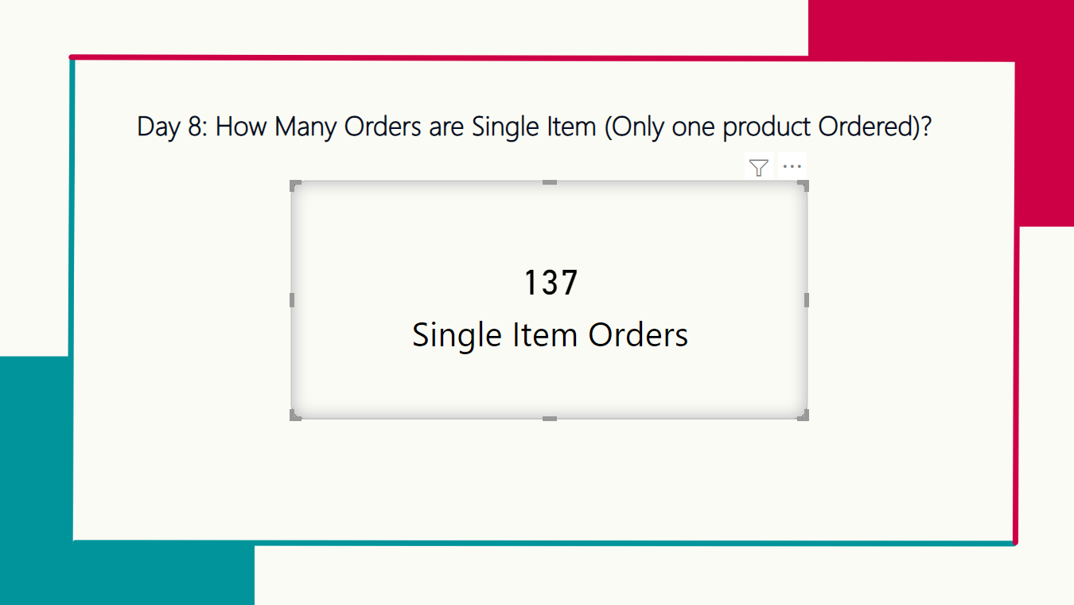  
  
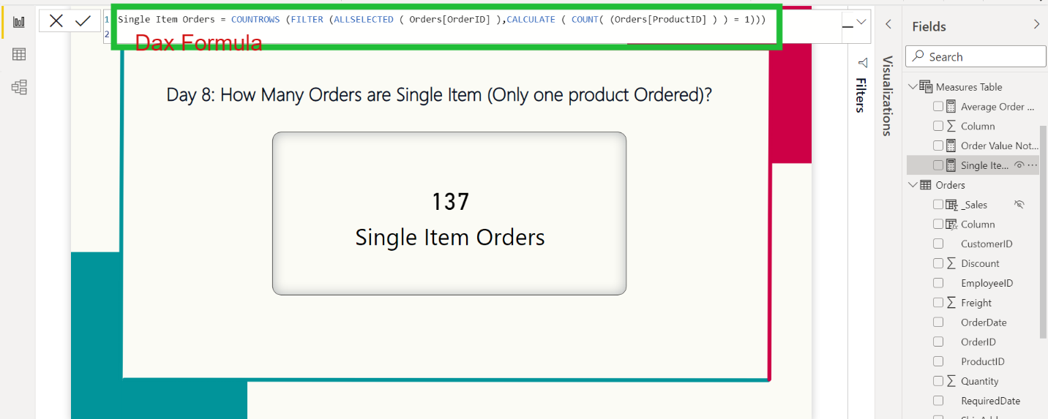  
  
  
Day 9: Average Sales Per Transaction for "Romero y Tomillo"?  
Ans : 104.81  
Dax formula: CALCULATE(AVERAGEX(Orders,Orders[_Sales]),FILTER(Customers,Customers[CompanyName]="Romero y Tomillo"))

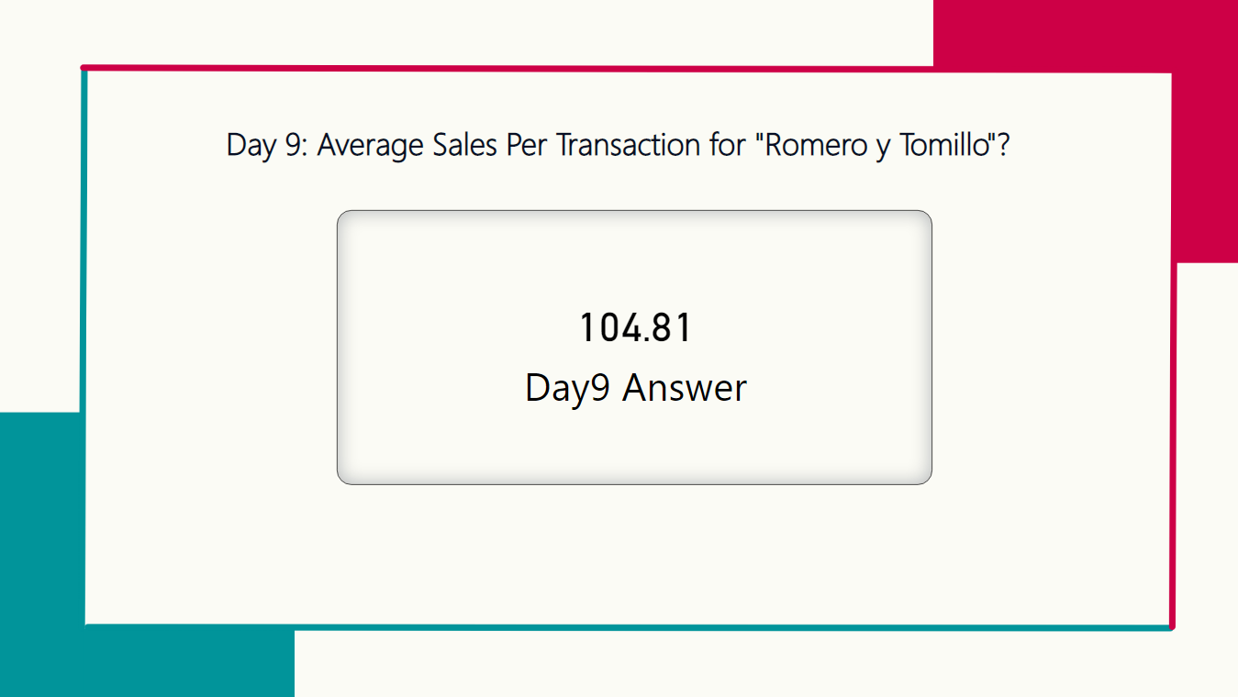  
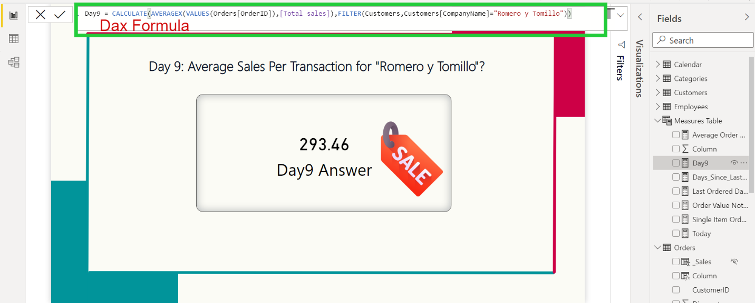  
  
  
  
  
  
Day 10 : How Many Day since "North/South" Last Purchase?  
ans : 18 days  
  
dax formula : Var a =CALCULATE(MAX(Orders[OrderDate]),FILTER(Orders,Orders[ShipName]="North/South"))

Var b = today()

Var c =DATEDIFF(a,b,DAY)

return c  
  
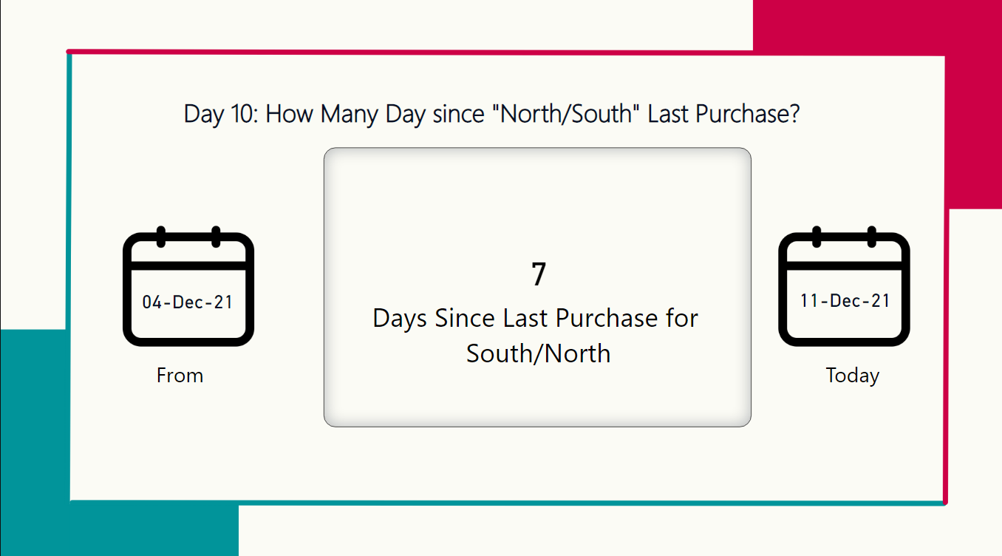  
  
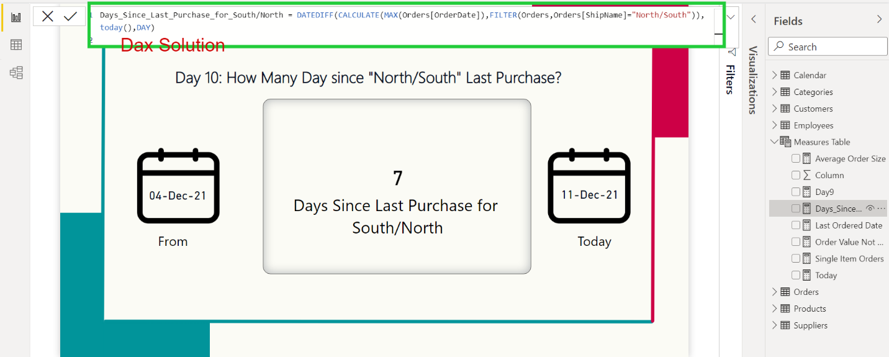

Day 11: How Many Customer have Ordered only Once?  
ans:1  
Dax formula :   
COUNTROWS(FILTER(SUMMARIZE(orders,Orders[CustomerID],"Distinctcount",DISTINCTCOUNT(Orders[OrderID])),[Distinctcount]=1))  
  
link : [D11 Customers that ordered only once | 25 Days of DAX Fridays! Challenge - YouTube](https://www.youtube.com/watch?v=2irH3aJgyQ4)  
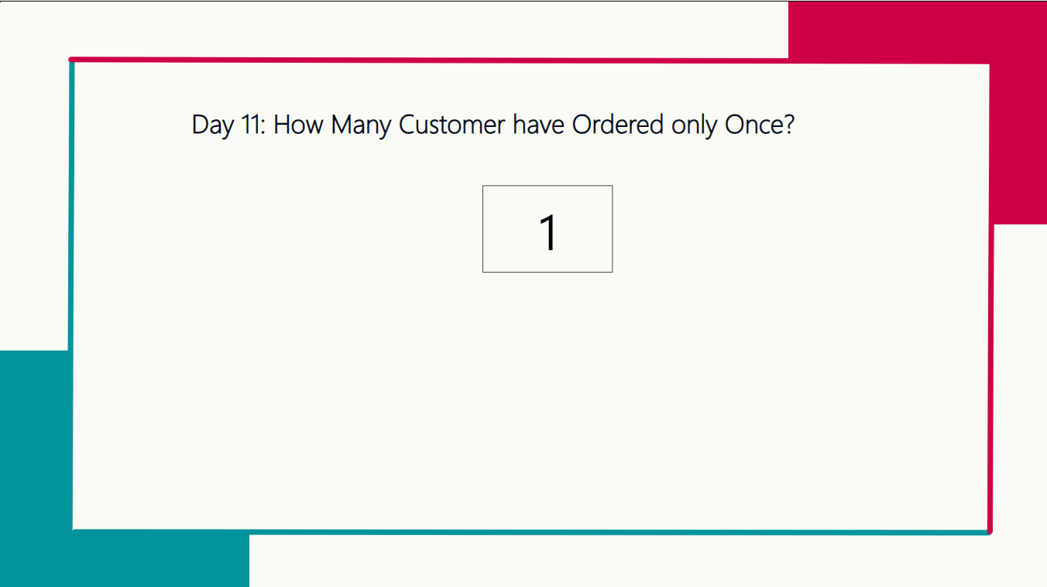  
  
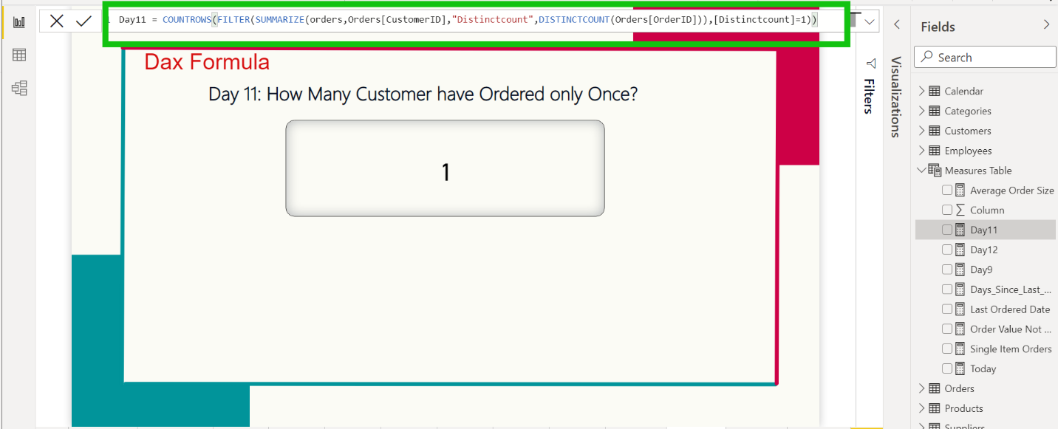  
  
  
Dax 12 : How Many New Customer(First purchase in current year) in 2021?  
Ans : 8  
dax formula : Day12 = Sumx(customers,If(calculate (year(FIRSTDATE(Orders[OrderDate])))=2021,1,0))

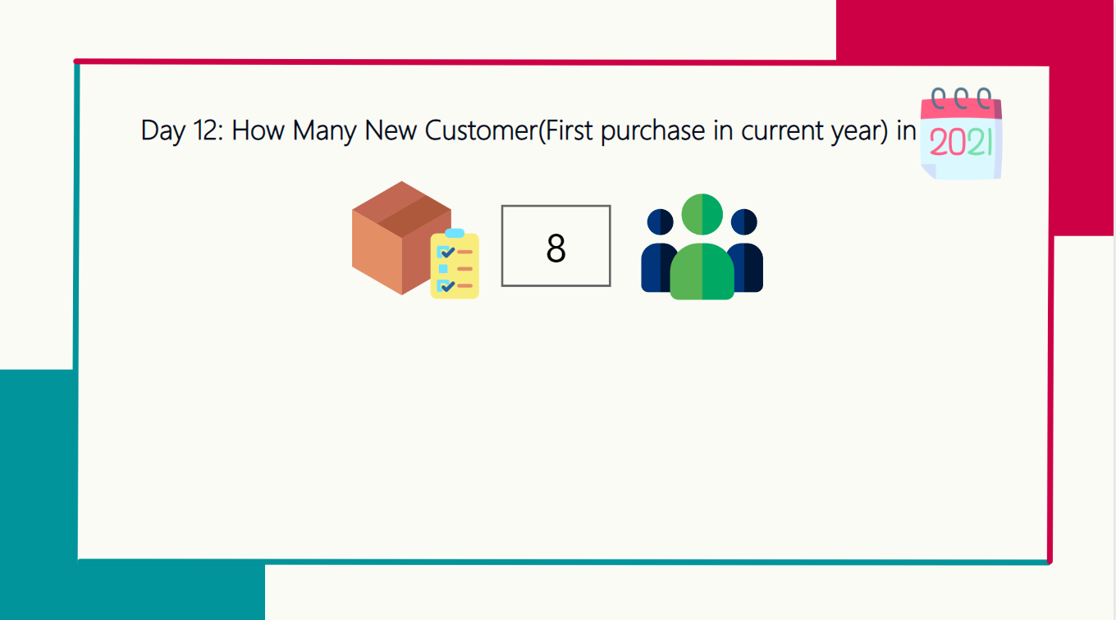  
  
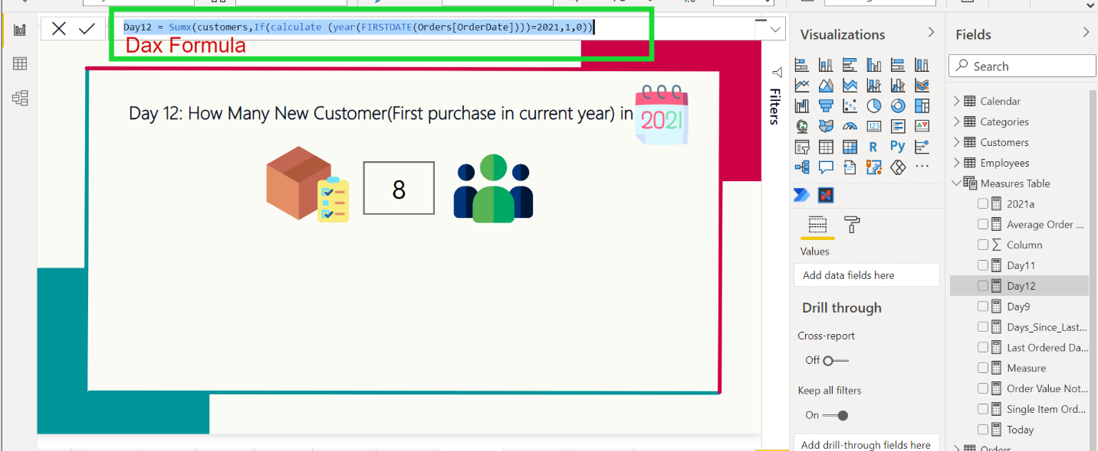

Day13:  
Ans 2  
dax Solution  
  
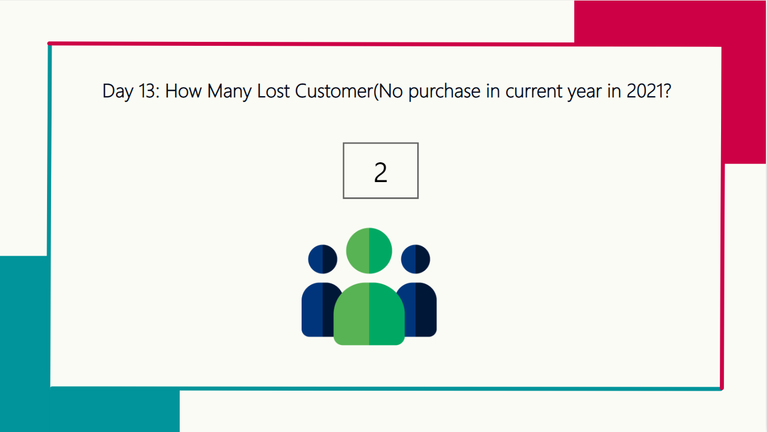

Dax 14: Day 14: How Many Customer have Never purchased Queso Cabrales?  
ans : 59  
dax solution : var Allcustomers = Values(Customers[CustomerID])

var QCCustomers = CALCULATETABLE(VALUES(Orders[CustomerID]),FILTER(ALL(Orders),Orders[ProductID]=11))

return

CALCULATE(DISTINCTCOUNT(Customers[CustomerID]),EXCEPT(Allcustomers,QCCustomers))

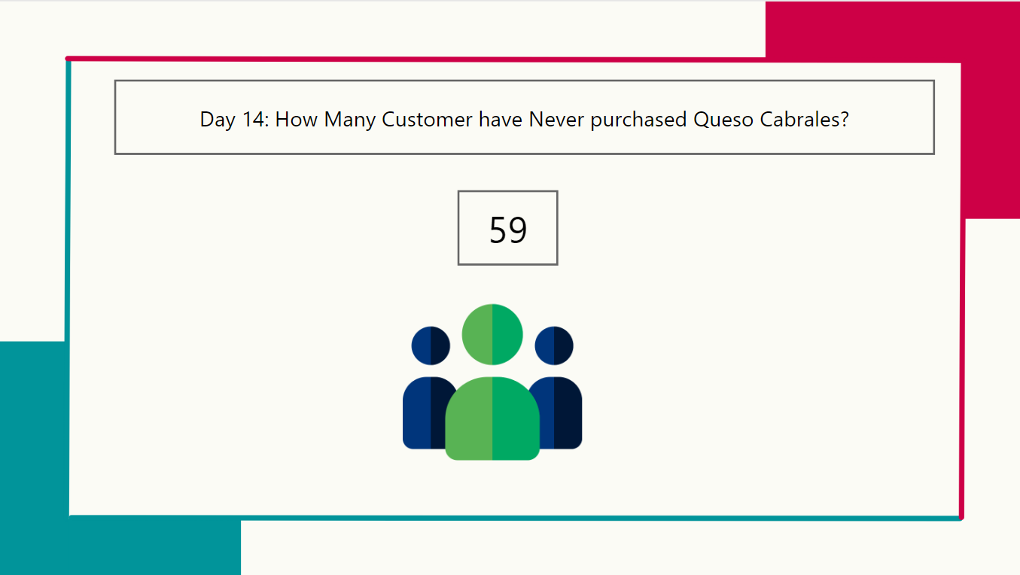

Day 15: How Many Customer have purchased only Queso Cabrales?  
ans 5  
dax : VAR singleorder =

SUMMARIZE(

FILTER( SUMMARIZE(Orders,Orders[OrderID],Orders[CustomerID],"Count Product",COUNTA(Products[ProductID])),[Count Product]=1),Orders[CustomerID],Orders[OrderID])

var qcpurchae= SUMMARIZE(FILTER(SUMMARIZE(Orders,Orders[OrderID],Orders[CustomerID],Orders[ProductID]),Orders[ProductID]=11),Orders[CustomerID],Orders[OrderID])

return

COUNTROWS(DISTINCT(INTERSECT(singleorder,qcpurchae)))

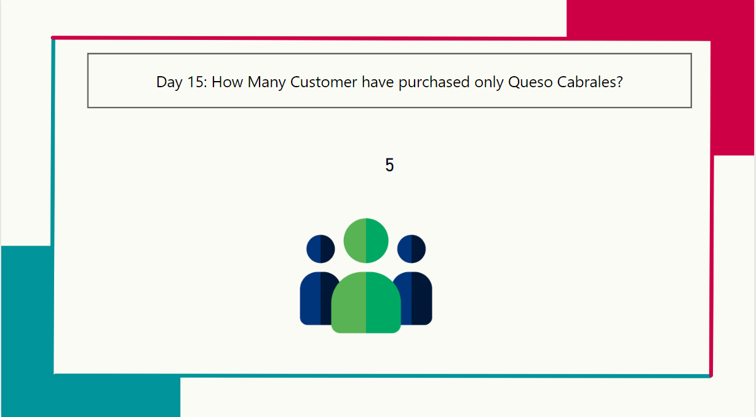  
  
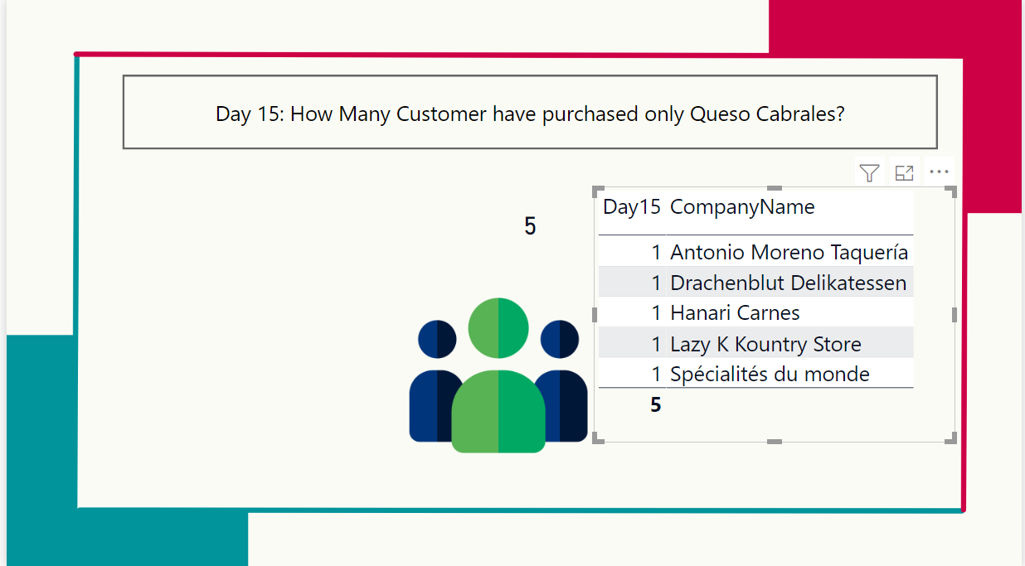  
  
  
  
Day 16 : How many Products are out of Stock?  
Ans: 5  
Dax solution: CALCULATE(COUNT(Products[UnitsInStock]),FILTER(Products,Products[UnitsInStock]=0))  
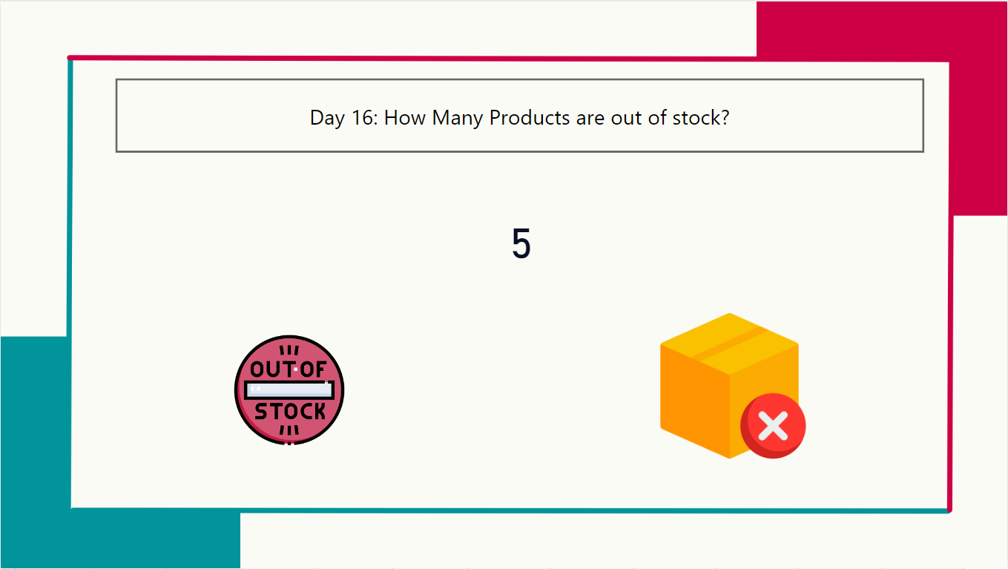

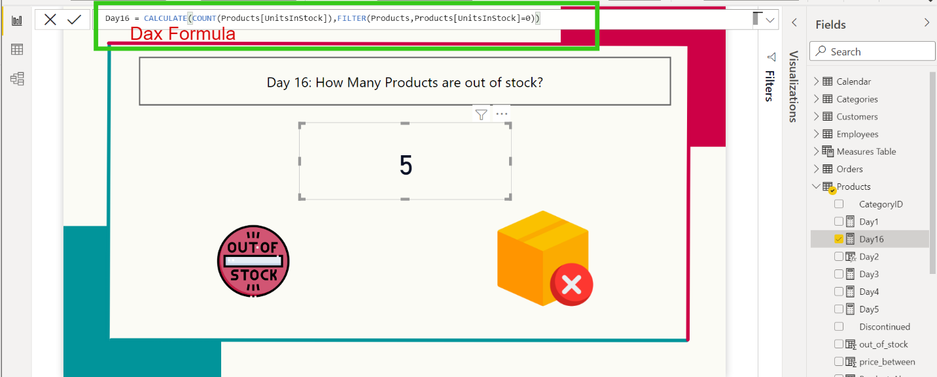  
  
  
  
  
  
  
Day17 How Many Products need to be restocked?(Based on Restock Level)  
ans 18  
dax solution :CALCULATE(COUNT(Products[ProductID]),FILTER(Products,Products[UnitsInStock]<Products[ReorderLevel]))  
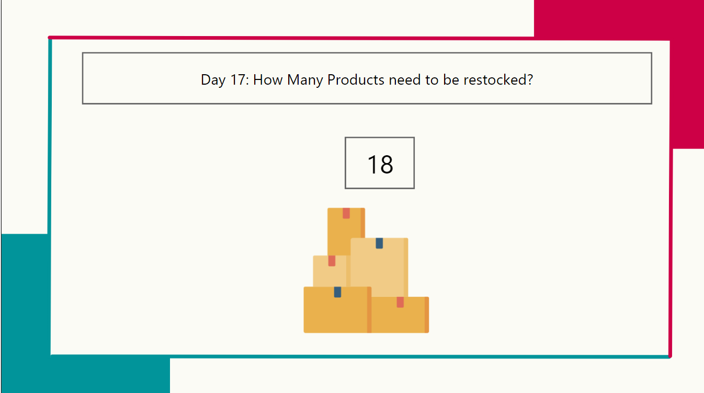  
  
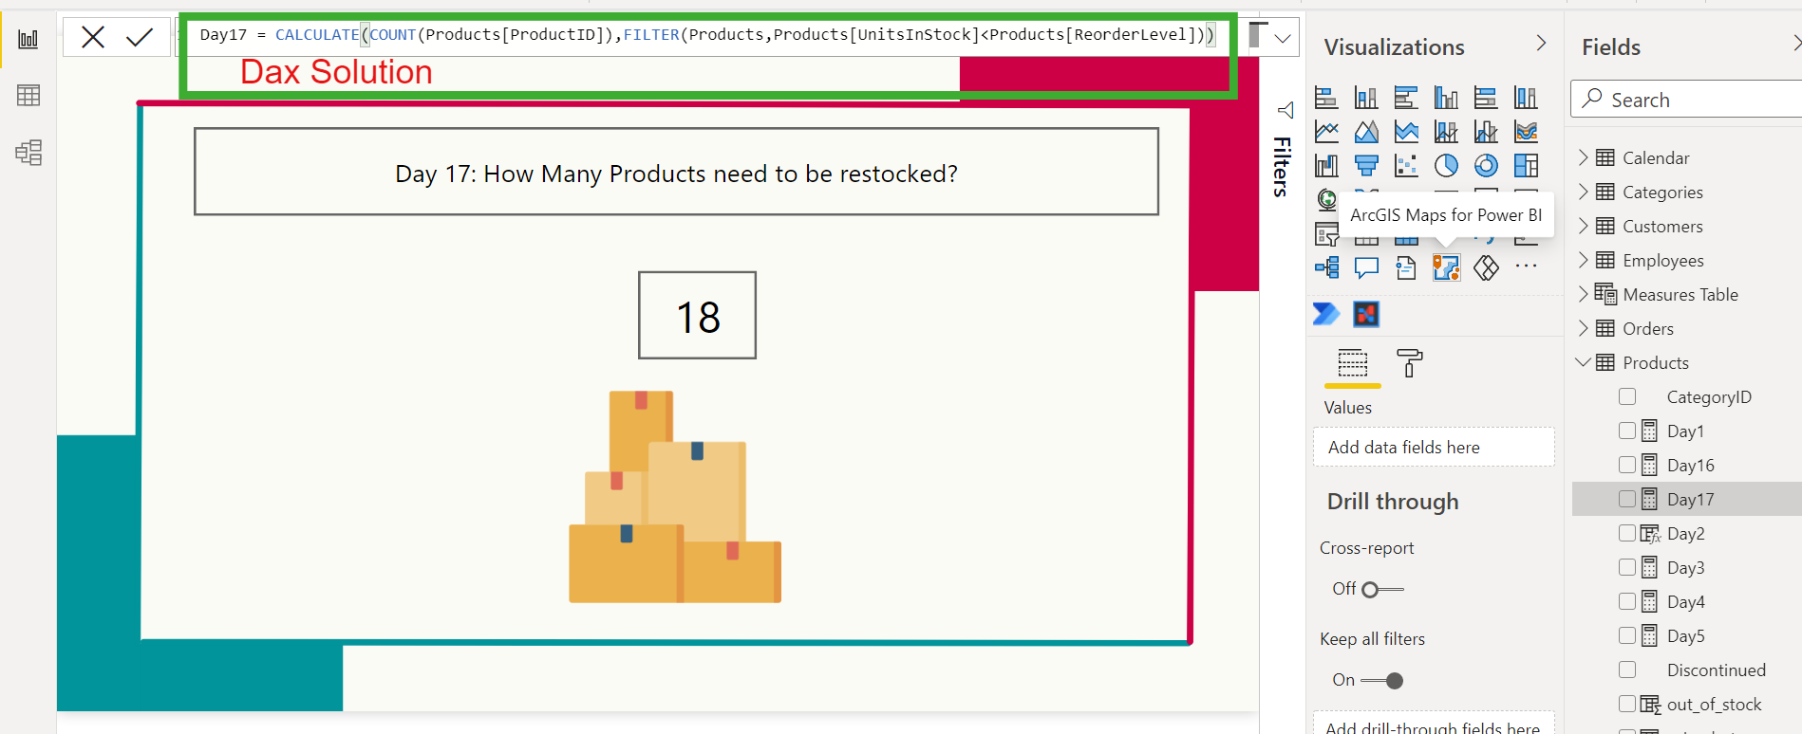  
  
  
Day 18 : How Many Products on Order we need to restock?  
Ans : 14  
Dax Solution: CALCULATE(COUNT(Products[ProductID]),FILTER(Products,Products[Units In Order]>Products[UnitsInStock]))  
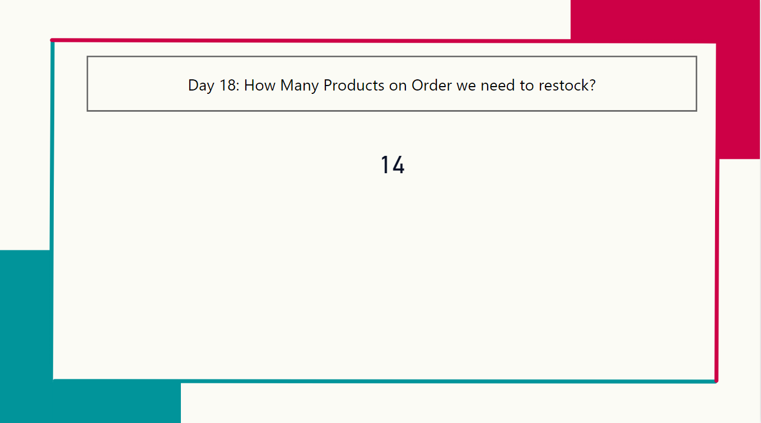  
  
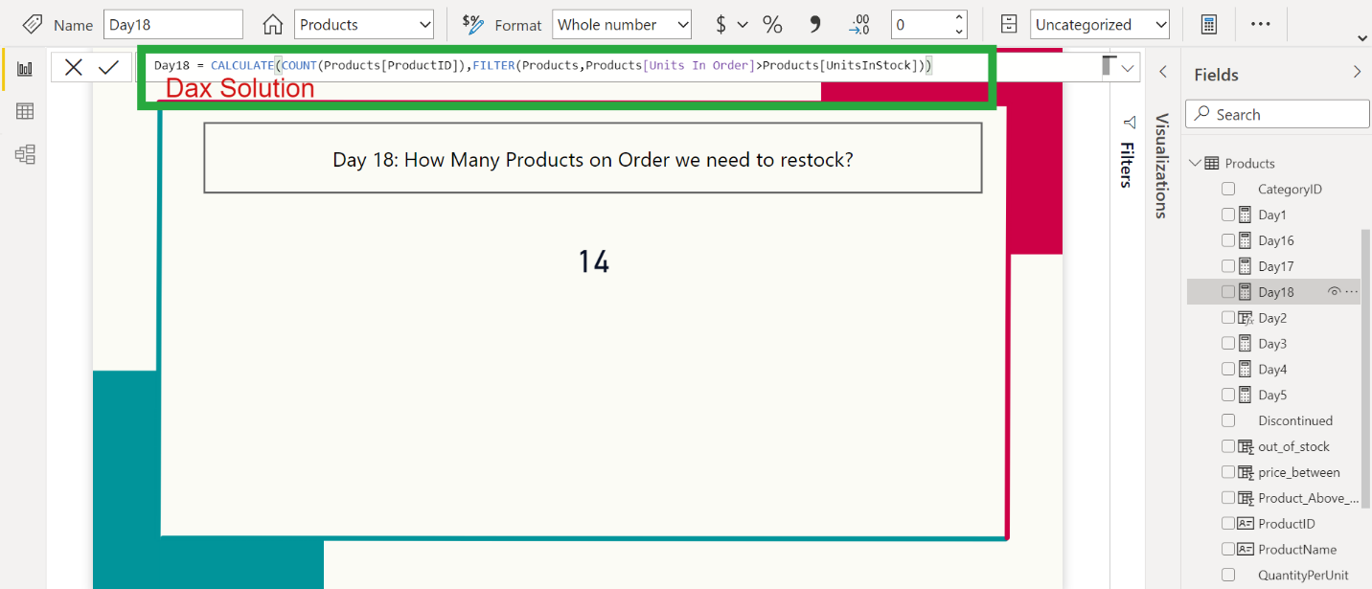  
  
  
Day 19: What is the Stocked value of Discontinued Products?  
Ans : 161.1  
Dax solution: CALCULATE(SUM(Products[Stock Value]),FILTER(Products,(Products[Discontinued]=True&& Products[UnitsInStock]<>0)))

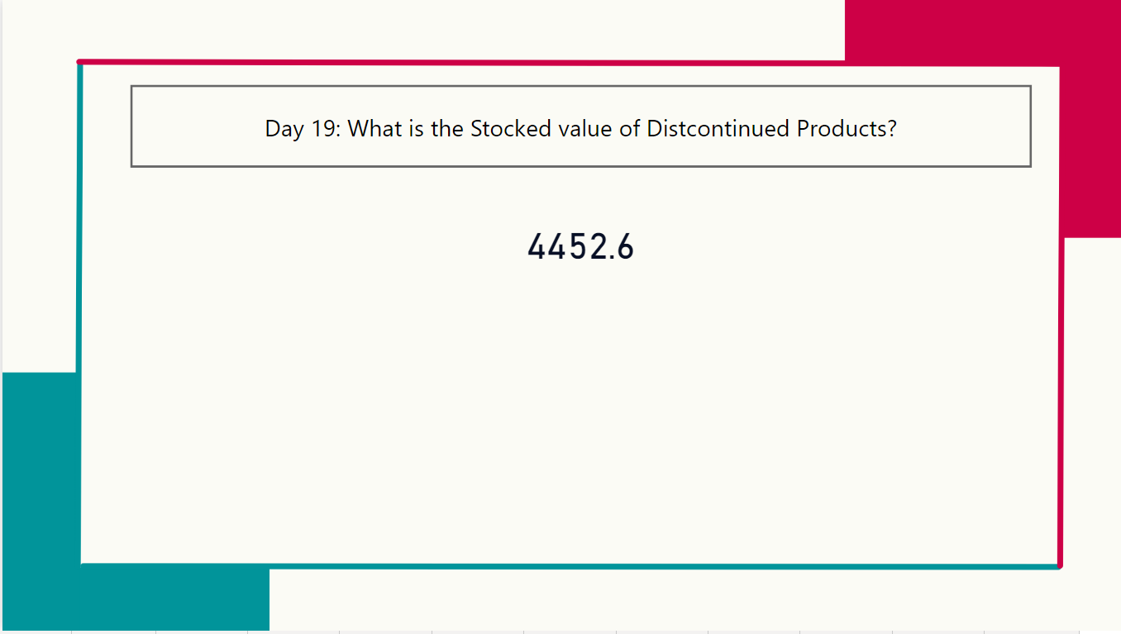  
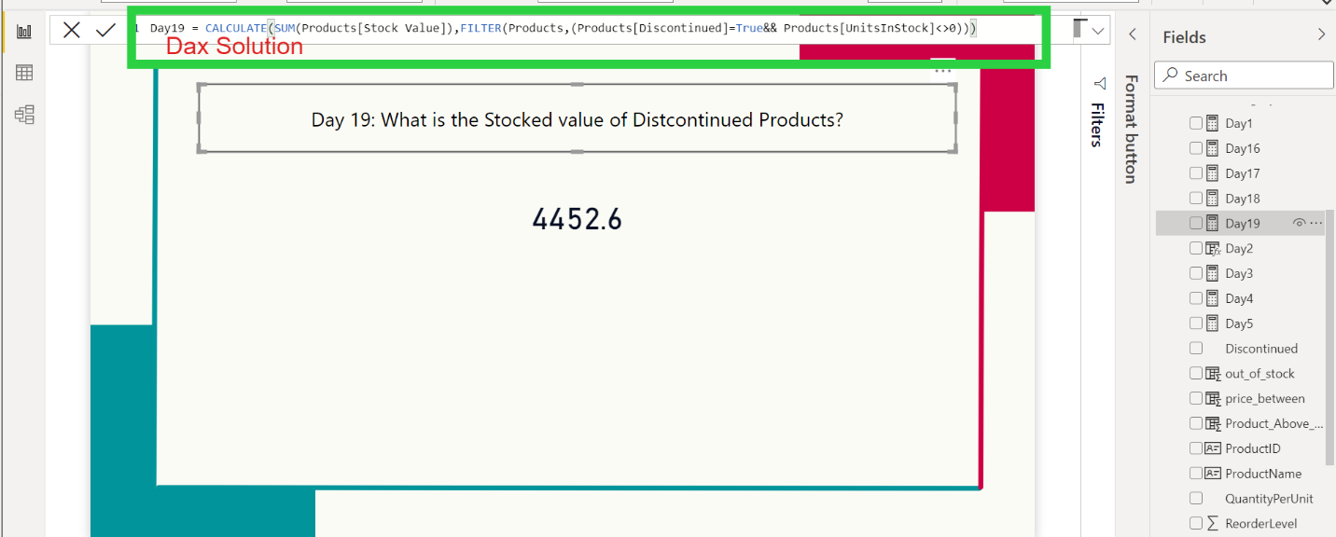  
  
Day 20: Which Vendor has the highest stock value?  
ans: 5721.5  
dax Solution :   
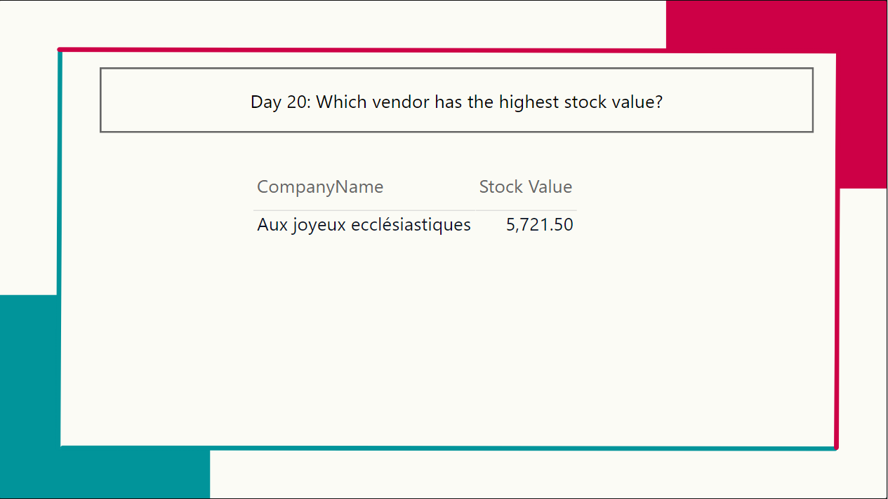  
  
  
Day 21: How many Employees(%) are Female?  
ans:55.56  
dax solution: CALCULATE(COUNT(Employees[Gender]),FILTER(Employees,Employees[Gender]="Female"))/COUNT(Employees[Gender])  
  
  
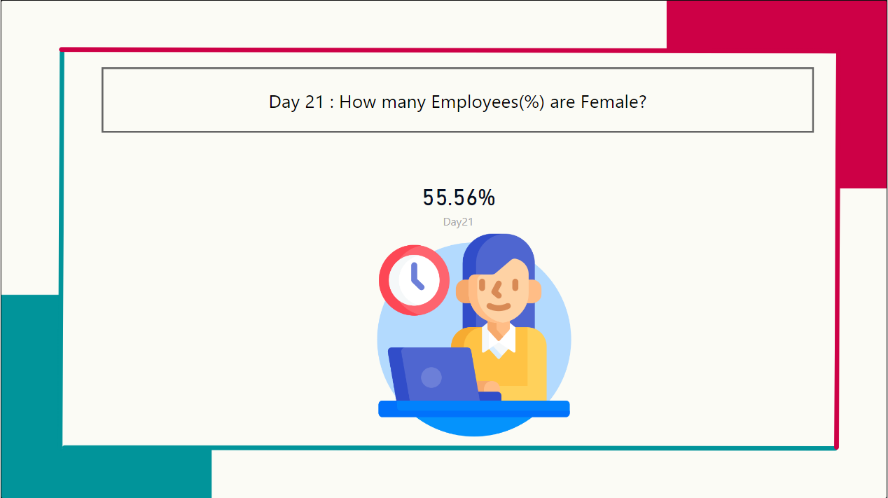  
  
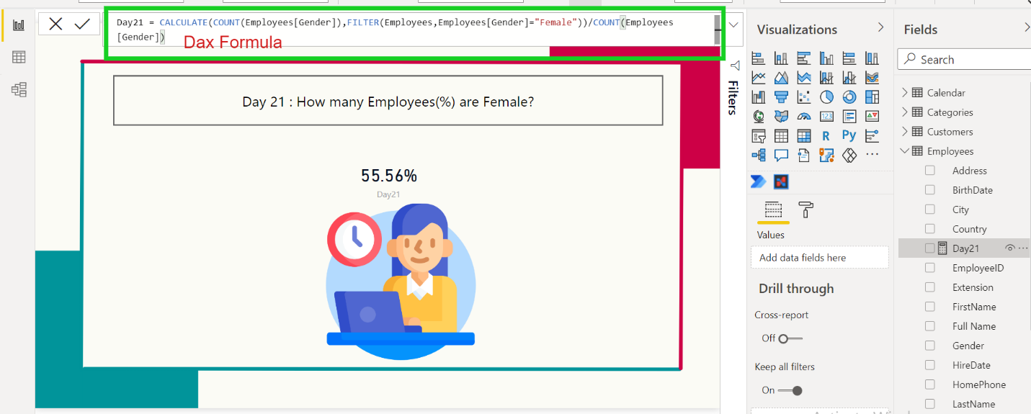  
  
  
Day 22: Day 22 : How many Employees are 60 years old or Over?  
ans : 6  
  
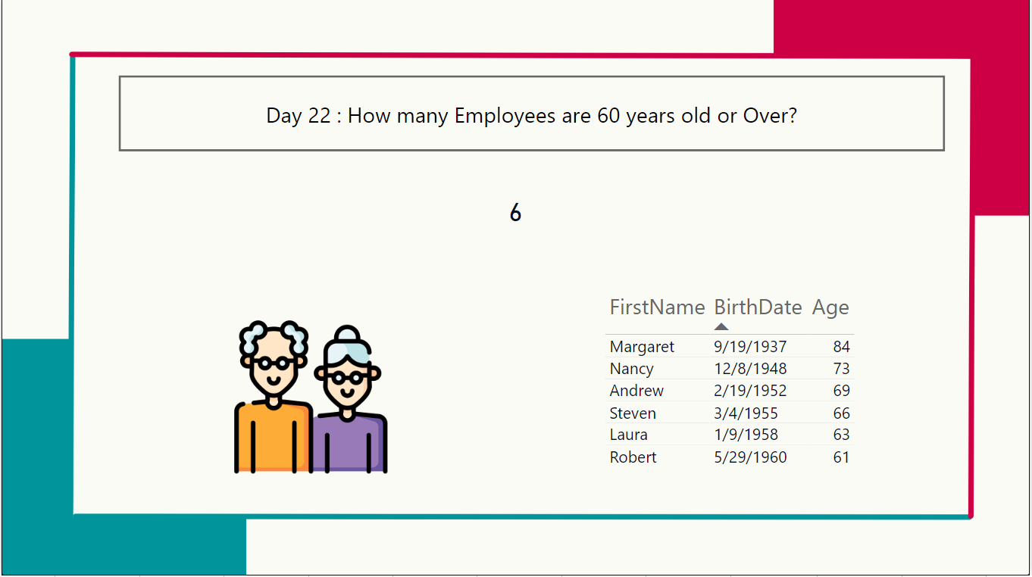  
  
  
Day 23 : Which Employee had the Highest ales in 2021?  
Ans : Nancy Davolio  
Dax Solution  
  
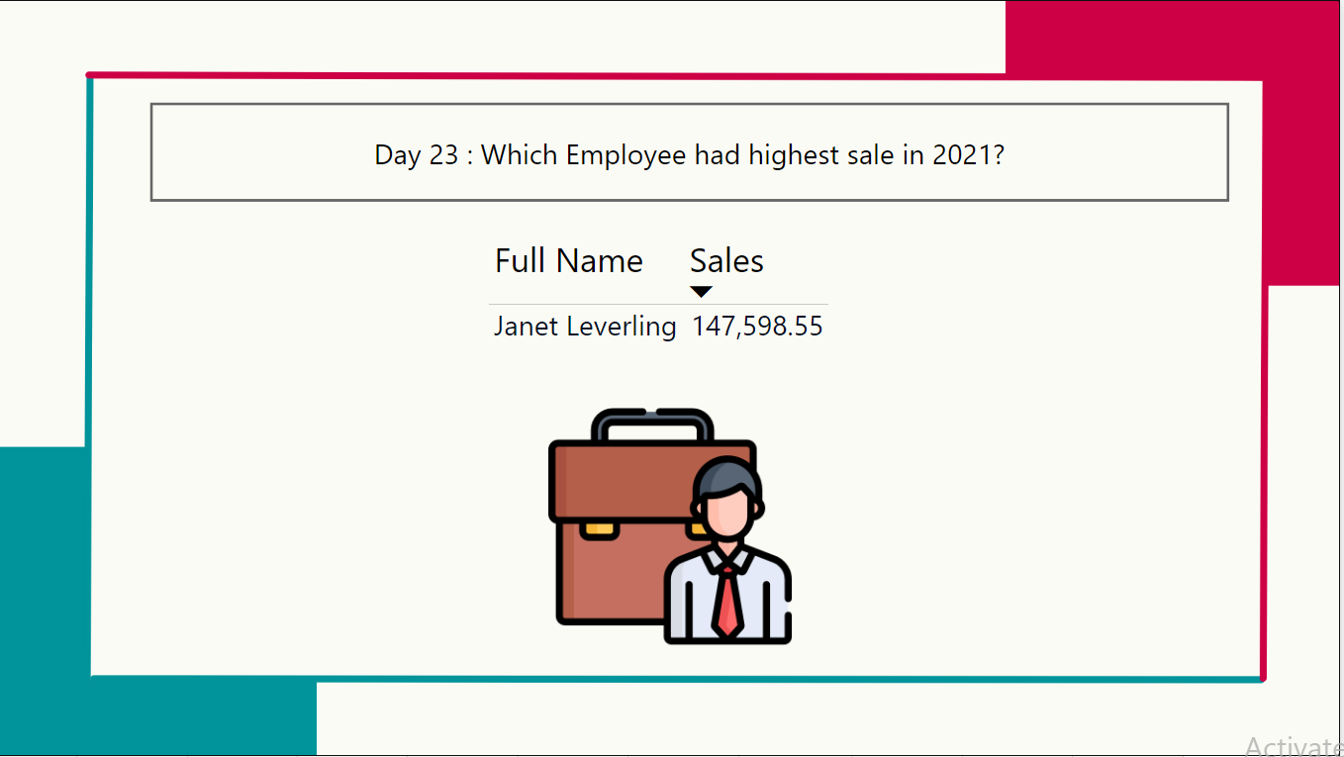  
  
  
Day24: How many employee sold over $100k in 2021?  
ans  
  
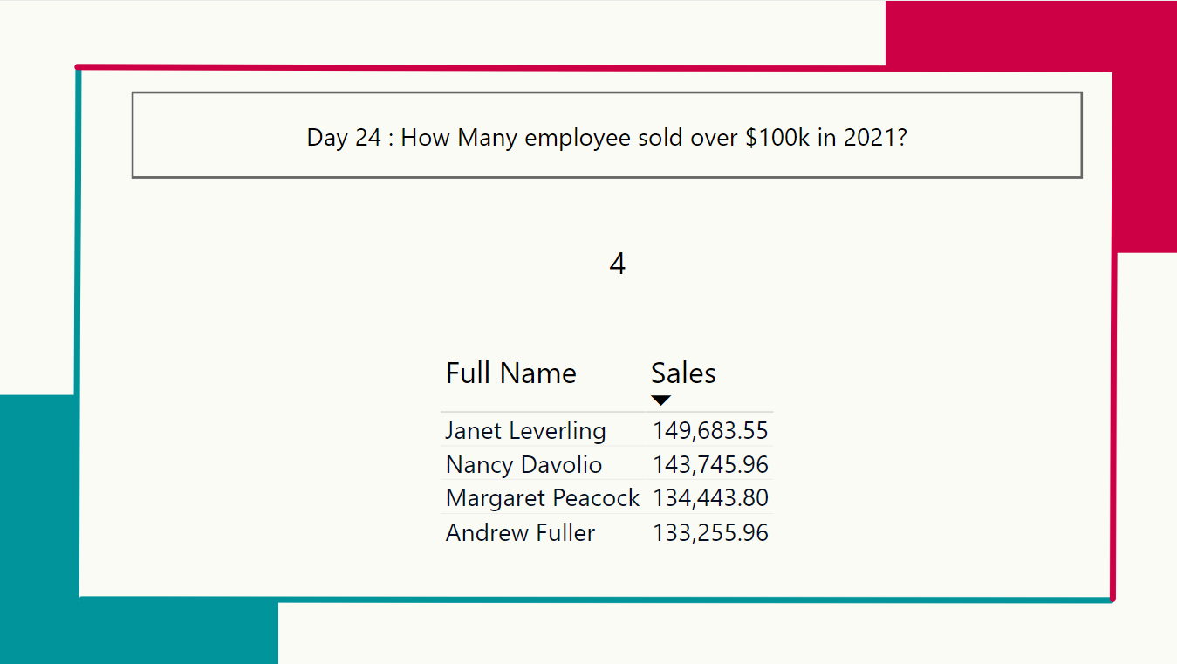  
  
Day 25 : How Many employees got hired in 1994?  
ans: 3  
